n  **PYTHON**

**Why python** ?.

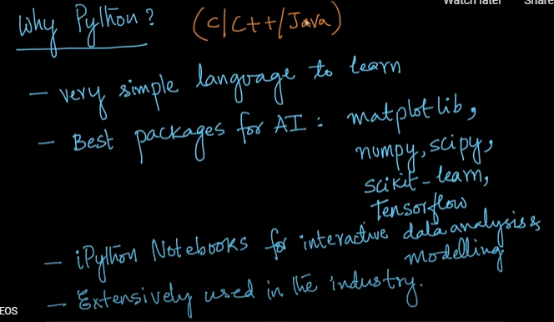

**Features of python:**

1.High level language(Normal english words that represent syntax)

2. Easy to learn

3.Graphical user interface

4.Case sensitive - (‘a’ differ from ‘A’)

5.Platform Independent

6.No compilation and linking

7.Object oriented programming

8.Fewer lines than ‘c’ language

9.No type declarations.(Ex: In c we declare data type but in python it is not necessary)

**Applications:**

1.Web development. 3.Business applications 5.Accessing the database

2.GUI development(Front end) 4.Games and 3D graphics

**1.KEYWORDS:**

a. Key words are the reserved words or predefined words given by the Interpretor (In c language it is called compiler).

b. These are the predefined words given by the interpretor having their own identity and specific task.

c. We can’t use keyword as a variable name or function name or as an identifier.

d. Keywords are case sensitive.

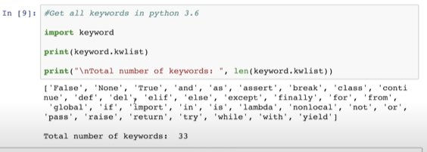

**2.IDENTIFIER:**

a. An identifier is a name given to entities like class, functions, variables, etc. It helps to differentiate one entity from another.(EX: Name and age speak of two different identifier in python)

Rules for writing identifiers

1. Identifiers can be a combination of letters in lowercase **(a to z)** or uppercase **(A to Z)** or digits **(0 to 9)** or an underscore _. Names like myClass, var_1 and print_this_to_screen, all are valid example.
2. An identifier cannot start with a digit. 1variable is invalid, but variable1 is a valid name.

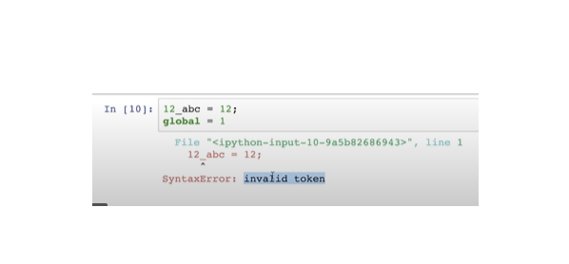C

1. Keywords cannot be used as identifiers.

global = 1

**Output**

File "<interactive input>", line 1

global = 1

^

SyntaxError: invalid syntax

1. We cannot use special symbols like **!**, **@**, **#**, **$**, **%** etc. in our identifier.

a@ = 0

**Output**

File "<interactive input>", line 1

a@ = 0

^

SyntaxError: invalid syntax

1. An identifier can be of any length.

Things to Remember:

a. Python is a case-sensitive language. This means, Variable and variable are not the same.

b. Always give the identifiers a name that makes sense. While c = 10 is a valid name, writing count = 10 would make more sense, and it would be easier to figure out what it represents when you look at your code after a long gap.

c. Multiple words can be separated using an underscore, like this_is_a_long_variable.

**COMMENTS IN PYTHON:**

a.Comments are the lines that exist in computer programs that are ignored by compilers and interpreters.

## b. Advantages of Using Comments

Using comments in programs makes our code more understandable. It makes the program more readable which helps us remember why certain blocks of code were written.

Other than that, comments can also be used to ignore some code while testing other blocks of code. This offers a simple way to prevent the execution of some lines or write a quick pseudo-code for the program.

Single-Line Comments in Python

In Python, we use the hash symbol # to write a single-line comment.

### Example 1: Writing Single-Line Comments

# printing a string

print('Hello world')

**Output**

Hello world

Here, the comment is:

# printing a string

This line is ignored by the Python interpreter.

Everything that comes after # is ignored. So, we can also write the above program in a single line as:

print('Hello world') #printing a string

The output of this program will be the same as in **Example 1**. The interpreter ignores all the text after #.

Multi-Line Comments in Python:

Python doesn't offer a separate way to write multiline comments. However, there are other ways to get around this issue.

We can use # at the beginning of each line of comment on multiple lines.

### Example 2: Using multiple #

# it is a

# multiline

# comment

Here, each line is treated as a single comment and all of them are ignored.

String Literals for Multi-line Comments

Even though there is no unique way to write multiline comments in Python, we know that the Python interpreter ignores the string literals that are not assigned to a variable.So, we can even write a single-line comment as:

#this is a comment

'this is an unassigned string as a comment '

Here, we can see that the second line of the program is a string but is not assigned to any variable or function. So, the interpreter ignores the string.

In a similar way, we can use multiline strings (triple quotes) to write multiline comments.

The quotation character can either be ' or ".

### Example 3: Using String Literals to write Multi-line Comments

'''

I am a

multiline comment!

'''

print("Hello World")

Here, the multiline string isn't assigned to any variable, so it is ignored by the interpreter. Even though it is not technically a multiline comment, it can be used as one.

Python docstrings

Python docstrings are the string literals that appear right after the definition of a function, method, class, or module.

By convention, the triple quotes that appear right after the function, method or class definition are docstrings (documentation strings).  
Docstrings are associated with objects and can be accessed using the __doc__ attribute.

## Example 1: Docstrings

def square(n):

'''Takes in a number n, returns the square of n'''

return n**2

Here, the string literal:

'''Takes in a number n, returns the square of n'''

Inside the triple quotation marks is the **docstring** of the function square() as it appears right after its definition.

**Note:** We can also use triple """ quotations to create docstrings.

### Example 2: Printing docstring

def square(n):

'''Takes in a number n, returns the square of n'''

return n**2

print(square.__doc__)

**Output**

Takes in a number n, returns the square of n

How to Write Better Comments?

* Use comments to describe what a function does and not the specific details on how the function does it.
* Try to remove as many redundant comments as possible. Try writing code that can explain itself, using better function/variable name choice.
* Try to make the comments as short and concise as possible.

**Python Indentation**

* Most of the programming languages like C, C++, and Java use braces { } to define a block of code. Python, however, uses indentation.
* A code block (body of a [function](https://www.programiz.com/python-programming/function), [loop](https://www.programiz.com/python-programming/for-loop), etc.) starts with indentation and ends with the first unindented line. The amount of indentation is up to you, but it must be consistent throughout that block.
* Generally, four whitespaces are used for indentation and are preferred over tabs. Here is an example.

for i in range(1,11):

print(i)

if i == 5:

break

* The enforcement of indentation in Python makes the code look neat and clean. This results in Python programs that look similar and consistent.
* Indentation can be ignored in line continuation, but it's always a good idea to indent. It makes the code more readable. For example:

if True:

print('Hello')

a = 5

and

if True: print('Hello'); a = 5

* both are valid and do the same thing, but the former style is clearer compared to above one
* Incorrect indentation will result in IndentationError.

## **Python Statement**

* Instructions that a Python interpreter can execute are called statements.
* For example, a = 1 is an assignment statement. if statement, for statement, while statement, etc. are other kinds of statements which will be discussed later.

Multi-line statement

* In Python, the end of a statement is marked by a newline character. But we can make a statement extend over multiple lines with the line continuation character (\). For example:

a = 1 + 2 + 3 + \

4 + 5 + 6 + \

7 + 8 + 9

* This is an explicit line continuation. In Python, line continuation is implied inside parentheses ( ), brackets [ ], and braces { }. For instance, we can implement the above multi-line statement as:

a = (1 + 2 + 3 +

4 + 5 + 6 +

7 + 8 + 9)

* Here, the surrounding parentheses ( ) do the line continuation implicitly. Same is the case with [ ] and { }. For example:

colors = ['red',

'blue',

'green']

* We can also put multiple statements in a single line using semicolons, as follows:

a = 1; b = 2; c = 3

**Variable:**

* A variable is a named location in memory used to store some data(value).
* They are given unique names to differentiate between different memory locations .The rules for writing a variable name is same as the rules for writing identifiers in python .
* We don’t need to declare a variable before using it. In python we simply assign a value to a variable and it will exist .And we don’t even to have declare the datatype of the variable.This is handled internally according to the type of value we assign to the variable.

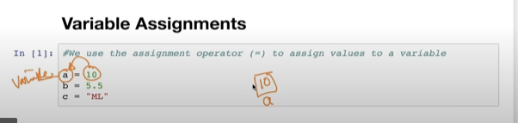

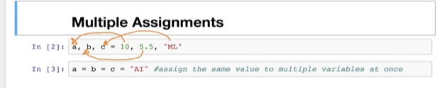

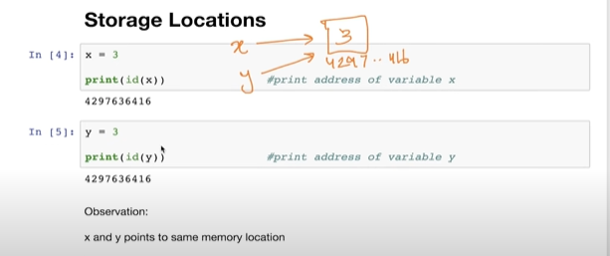

Now if we assign new value to y=2 then the variable y refers to the memory location [2]

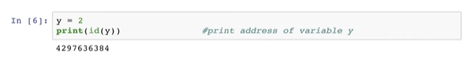

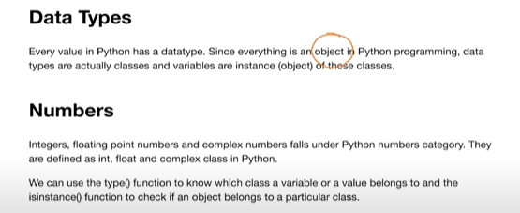

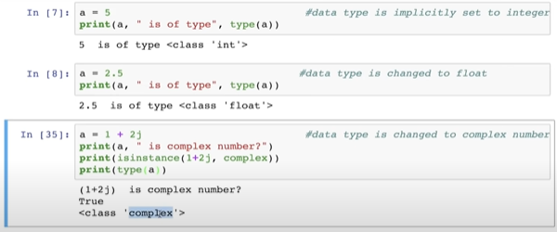

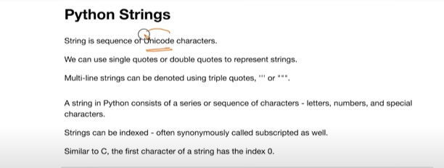

**Unicodes - is much larger collection of characters[ compared to ASCII code (American standard code for information interchange) ]like other language letters(chinese),emojis**

**Python strings store other than non english alphabetical characters ,other**

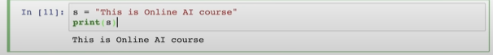

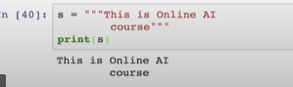

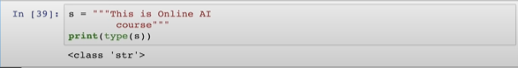

**Strings can also represented with in sigle quotes for single line string,as well as multi line strings in single triple quotes**

**The numbers present in Green colour represents index**

**0 1 2 3 4 5 6 7**

|  |  |  |  |  |  |  |  |
| --- | --- | --- | --- | --- | --- | --- | --- |
| **1** | **2** | **3** | **4** | **5** | **6** | **7** | **8** |

**.**

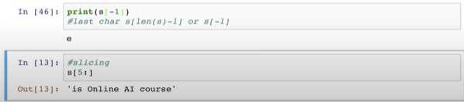

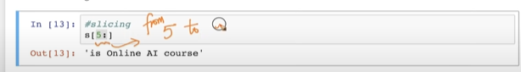

**Here space also counted while calculating index.**

|  |  |  |  |  |  |  |
| --- | --- | --- | --- | --- | --- | --- |
| **1** | **2** |  | **7** | **9** | **12** | **18** |

**0 1 2 3 4 5 6**

**Index =7**

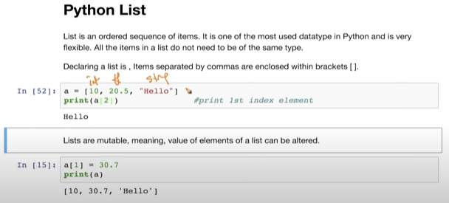

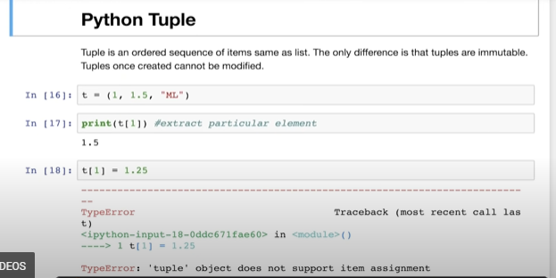

**Tuples are immutable .**

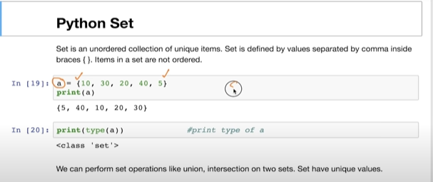

**s** 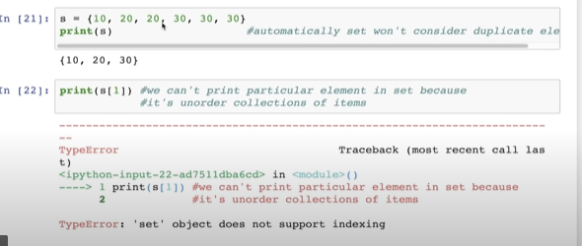

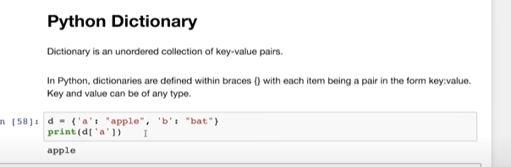

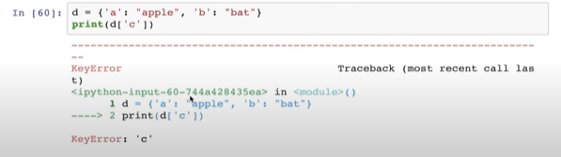

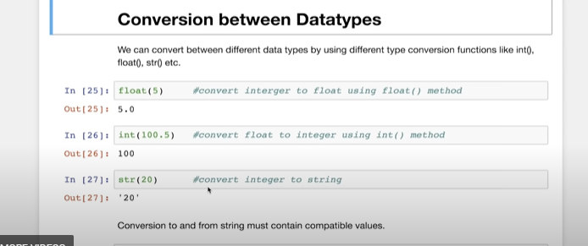

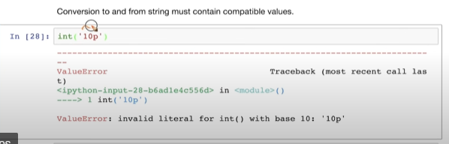

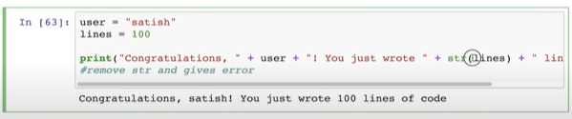

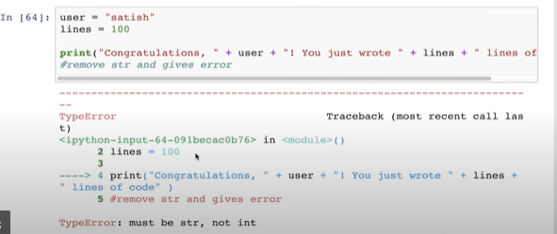

**If we remove str output will shows error**

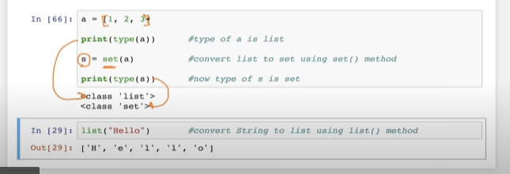

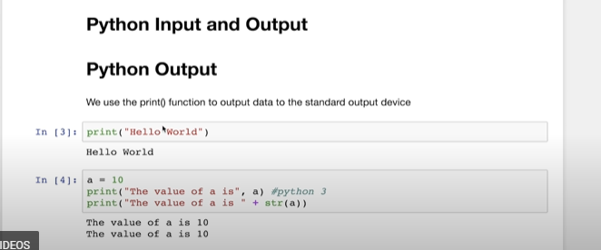

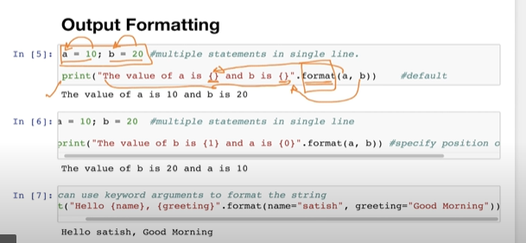

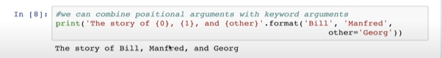

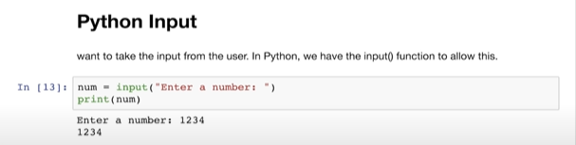

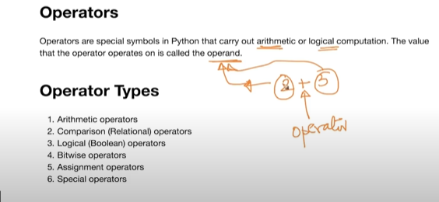

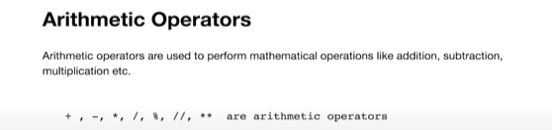

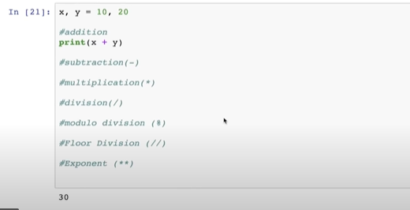

**//=floor division(15//2=7 but in the same case -15//2= -8)**

**%=modulo operator=(15%2=1 - - gives us remaider as the output)**

**/=Division =(15/2=7.5 - - gives us coefficient as the remainder)**

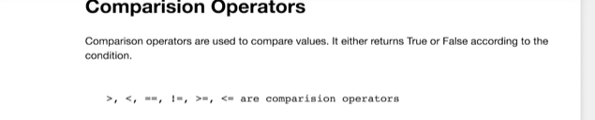

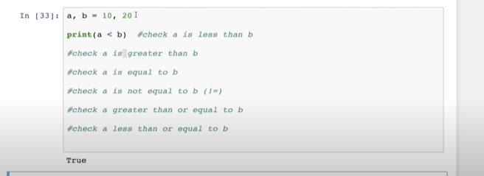

**The out put of comarision operator is a boolean type(Either true or False)**

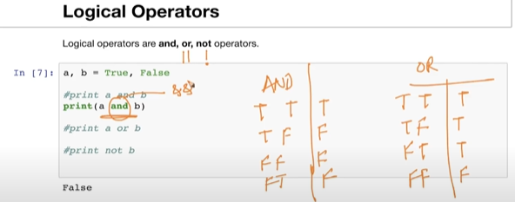

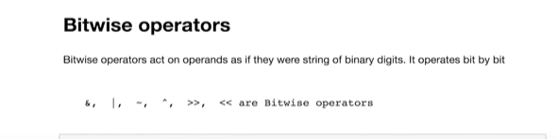

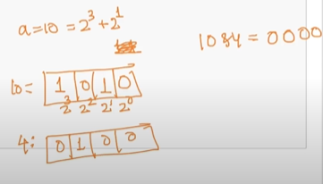

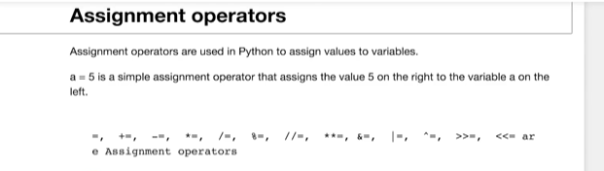

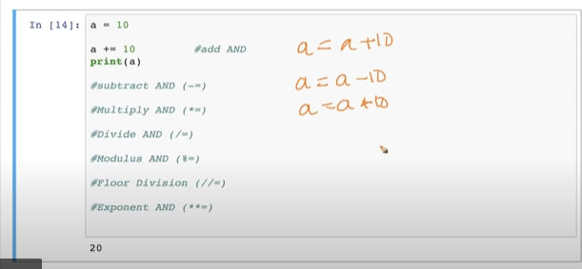

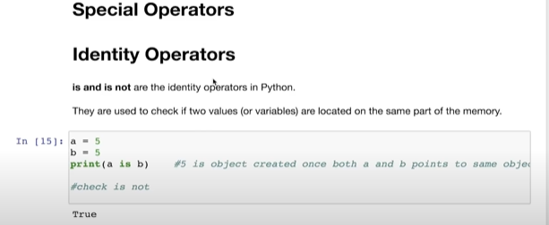

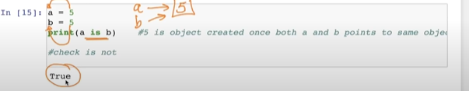

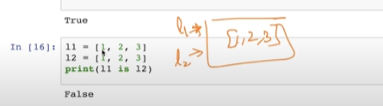

**For more complex datatypes(like tuples,sets,dict) it is not true**

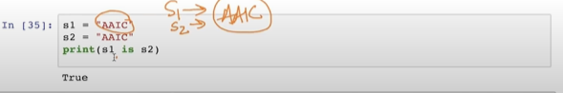

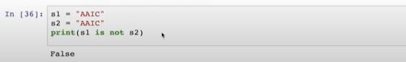

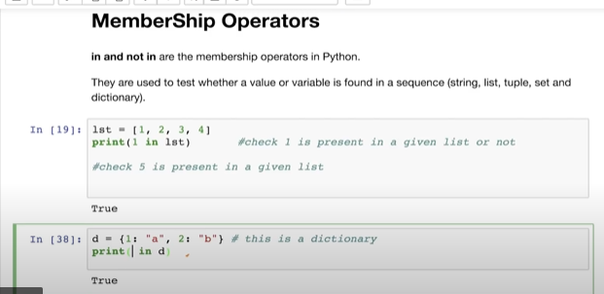

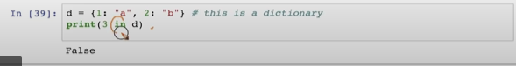

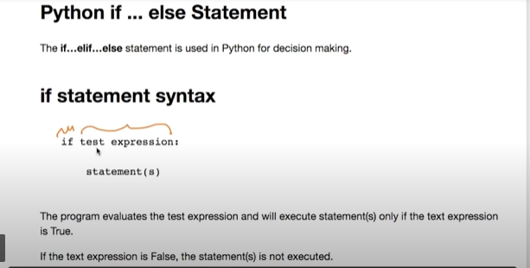



**1,-1 etc.,=Non-Zero Values**

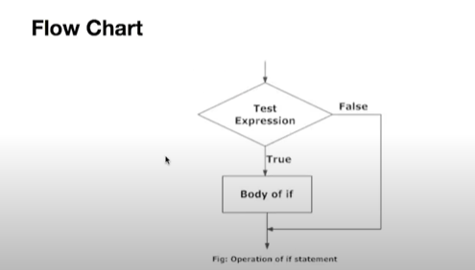

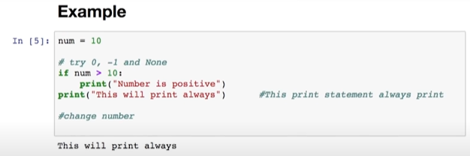

**If the condition satisfies it will follow the indentation rule and print the statement which Is next to the condition otherwise it goes to the next line .**

**In the place of condition if there is ‘0’ or none or false**

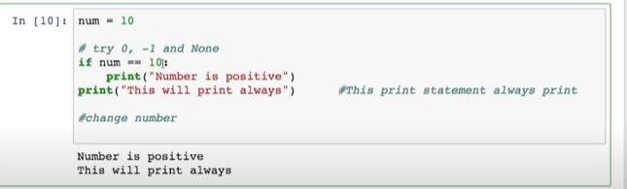

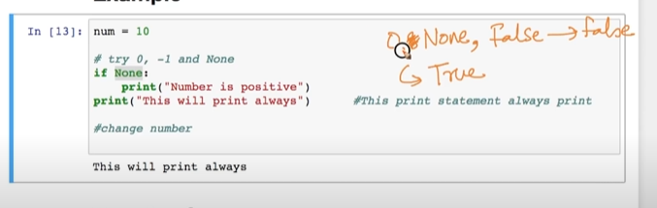

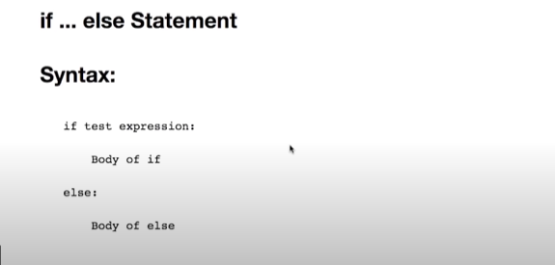

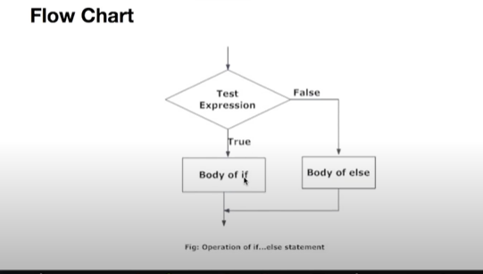

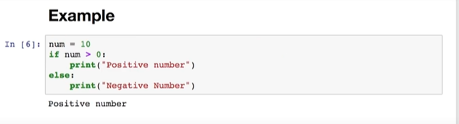

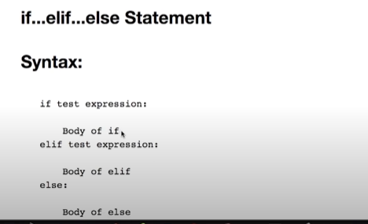

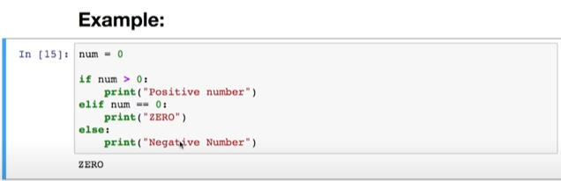

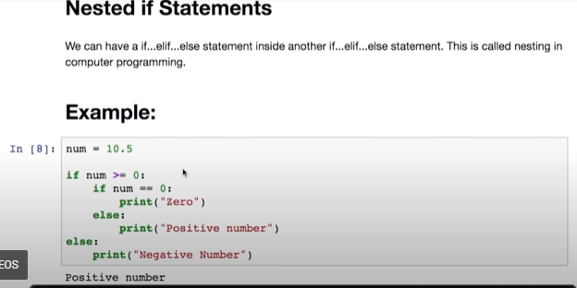

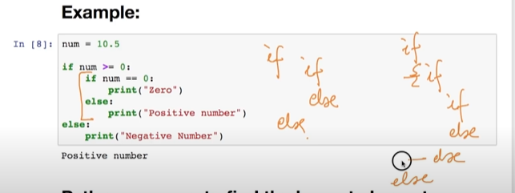

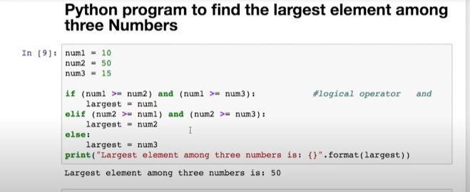

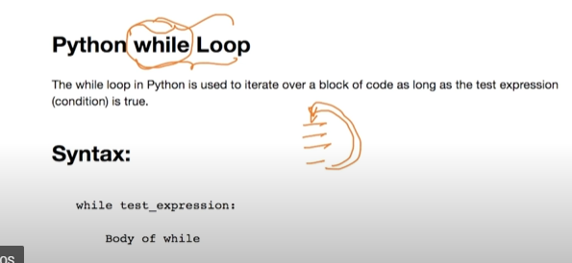

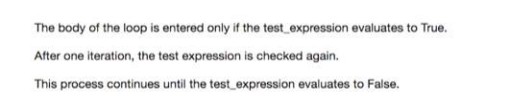

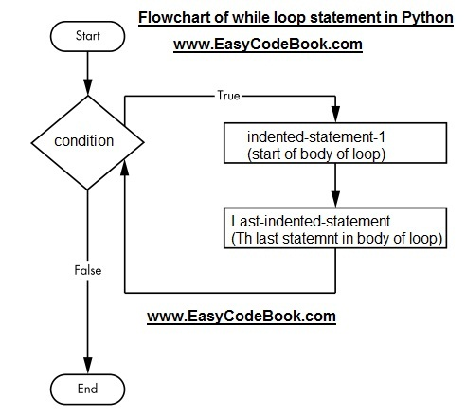

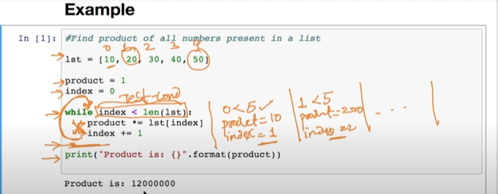

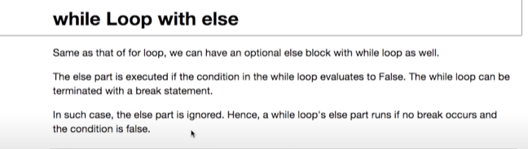

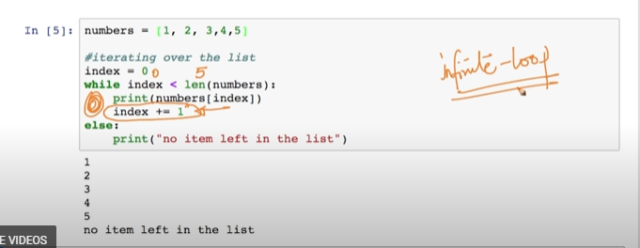

**Note :If we don’t mention index += 1 then the loop gets executed infinite times**

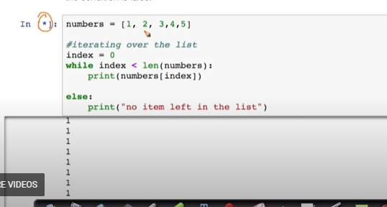

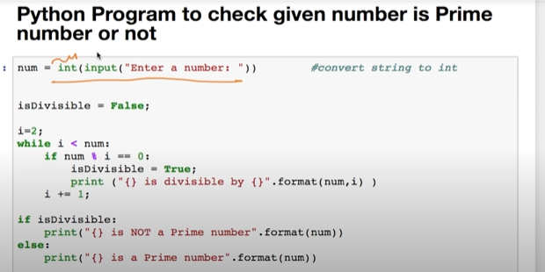

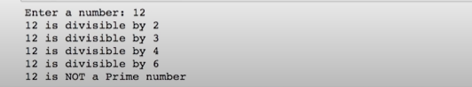

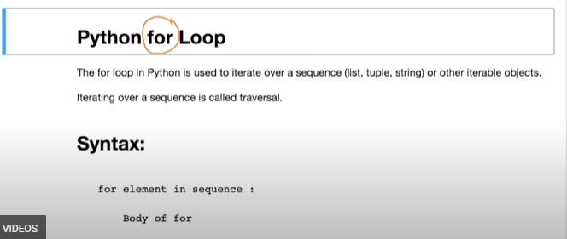

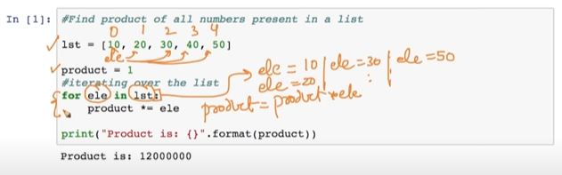

**It is more clear comparing to while loops**

**RANGE() Function**

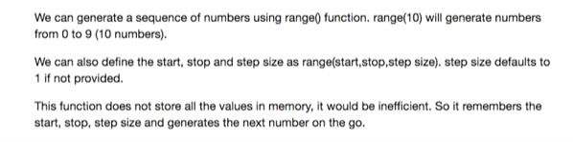

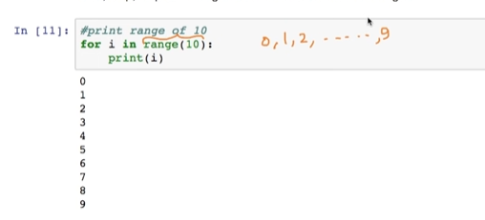

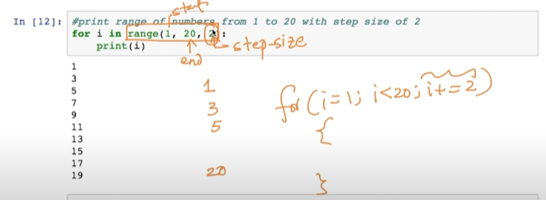

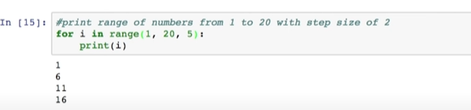

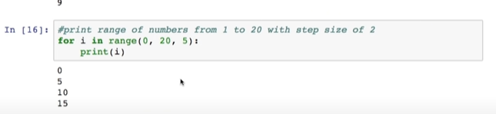

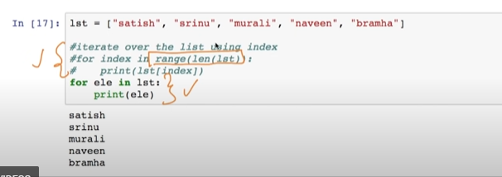



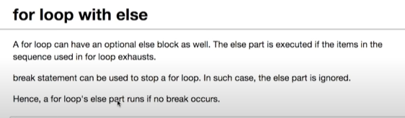

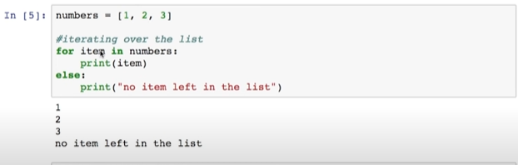

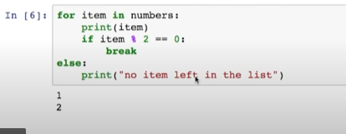

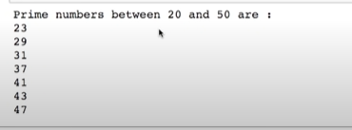



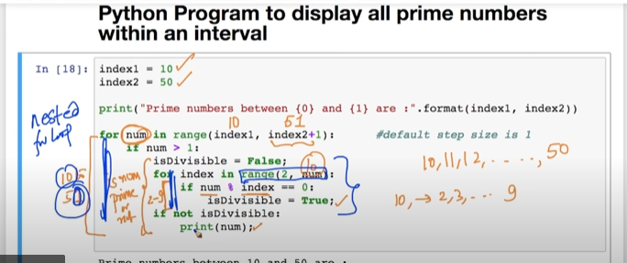



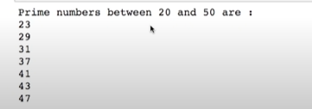

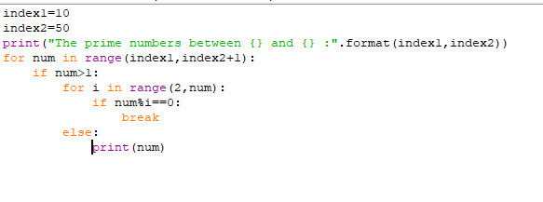

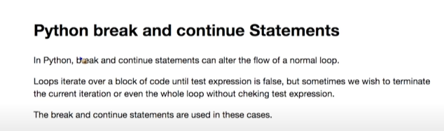

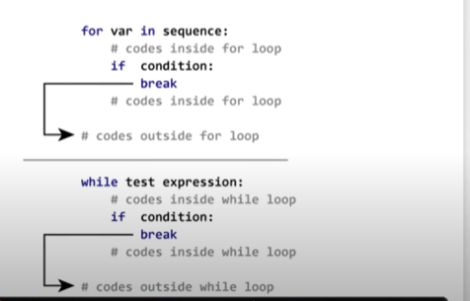

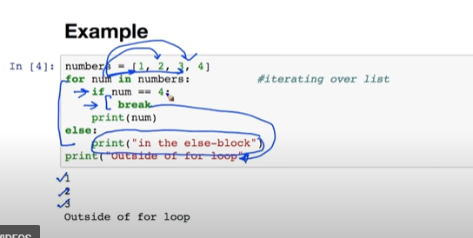

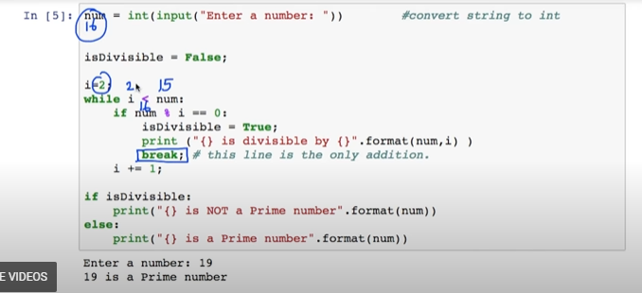

**By reducing the no of iterations by using break statement , time taken to run the program**

**Is much less**

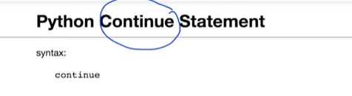

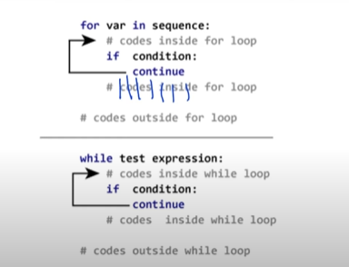

**Whenever the condition is satissfied it will skip the current iteration control again inters into loop**

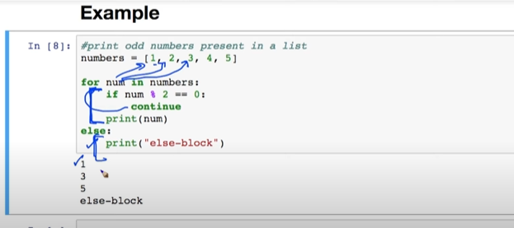

**IN_BUILT DATA STRUCTURES**

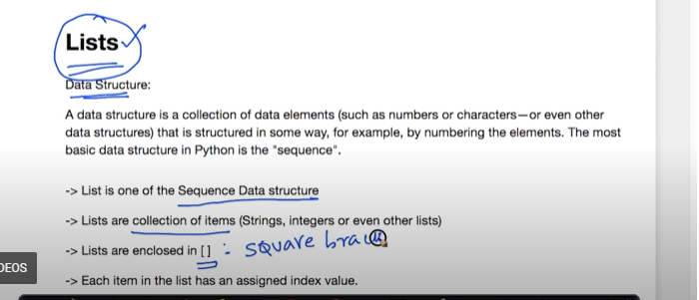

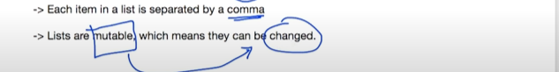

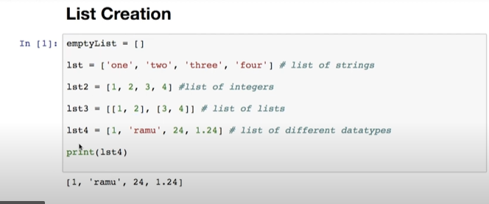

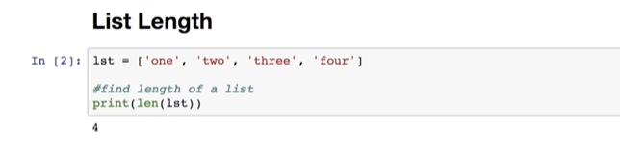

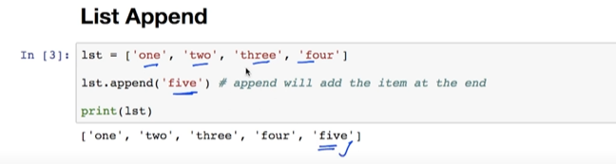

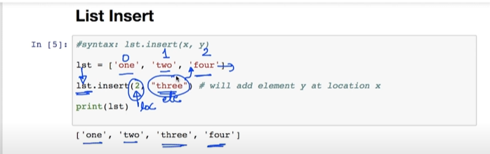

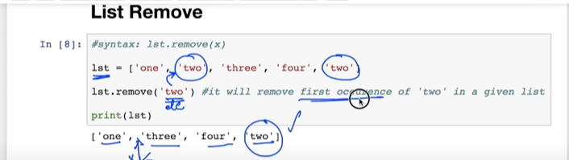

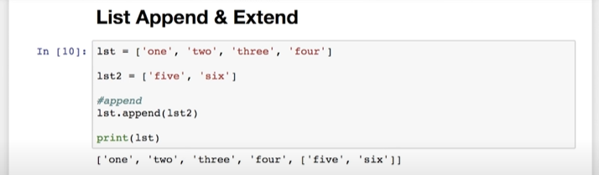

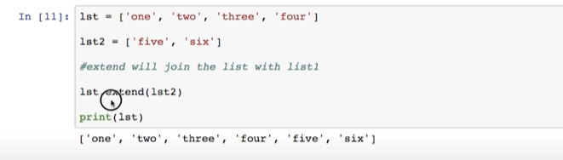

**Here list2 added to list1 as elements not as list at the end of list1**

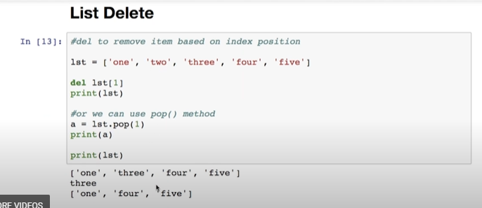

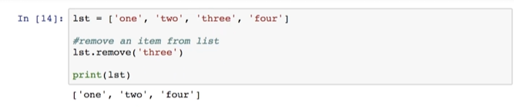

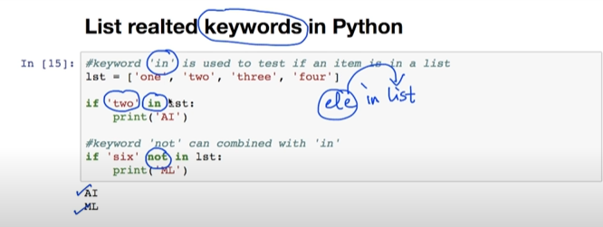

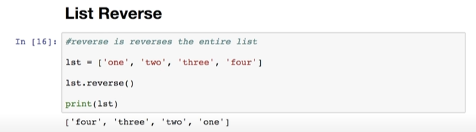

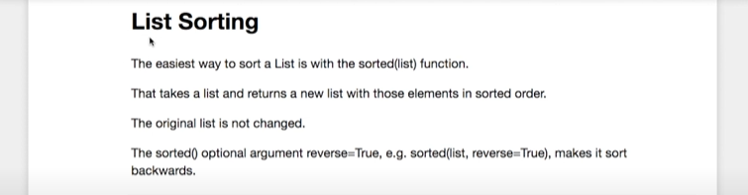

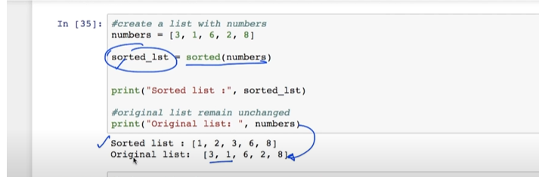

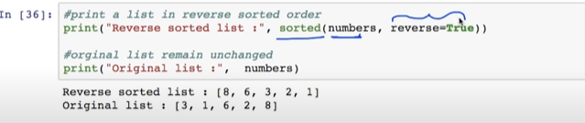

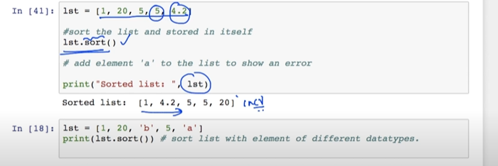

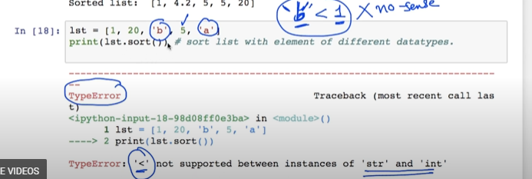

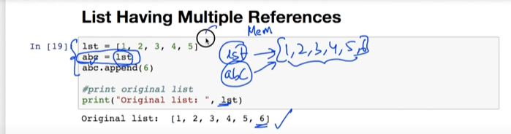

**What ever changes we made to the list(abc) ,the changes will made automatically to the original list.(this concept is similar to pointers in list)**

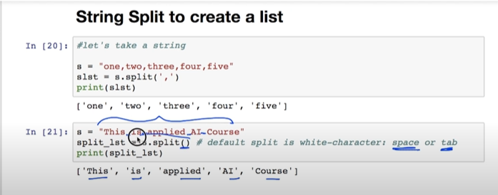

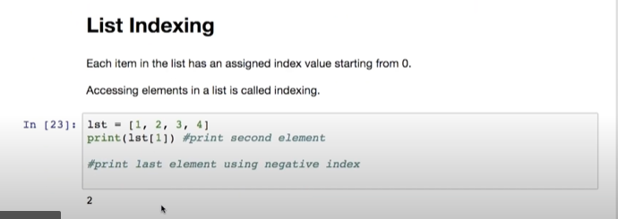

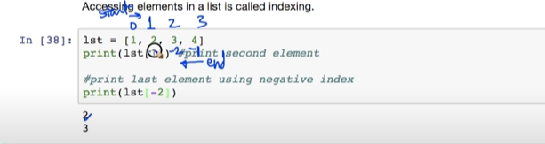

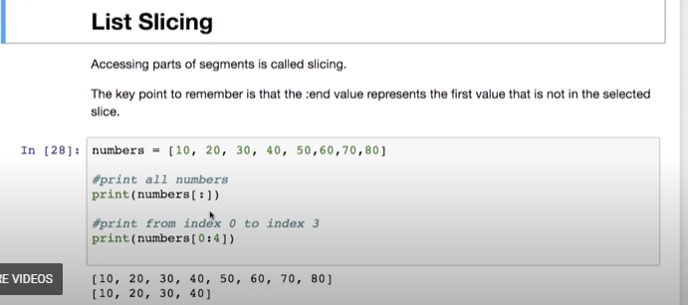

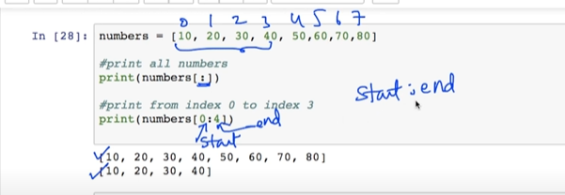

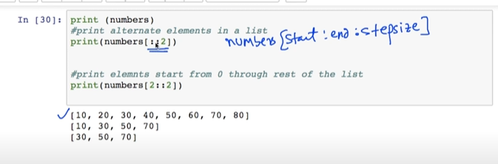

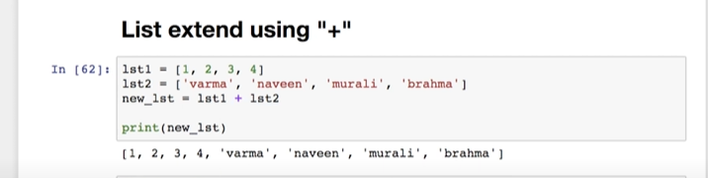

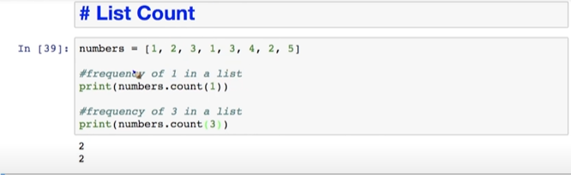

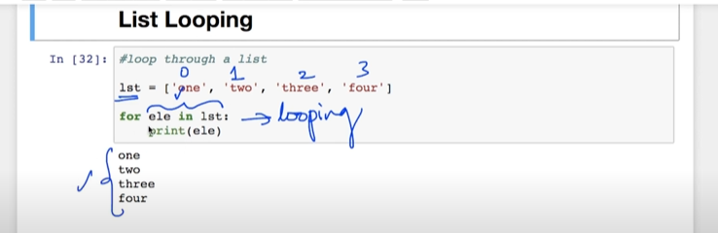

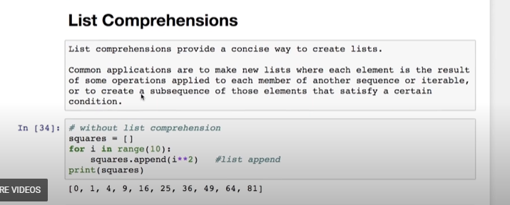

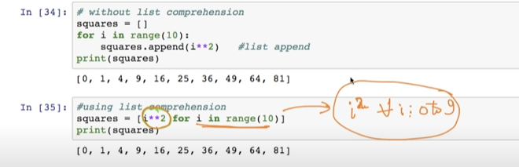

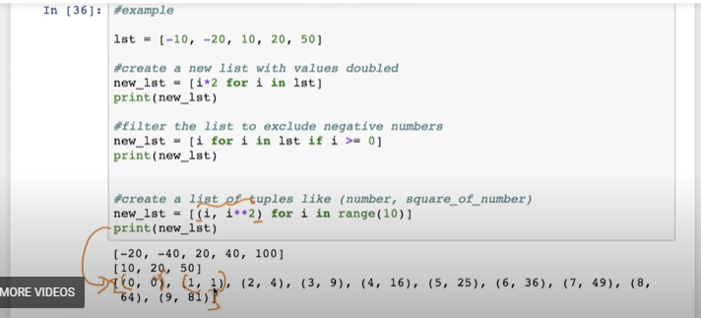

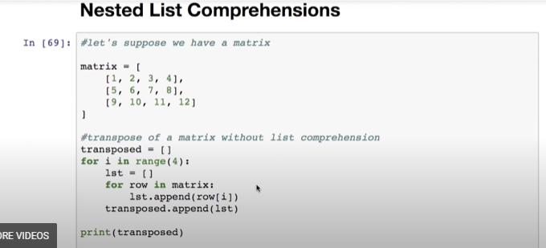

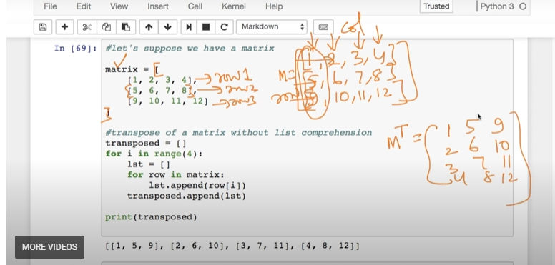

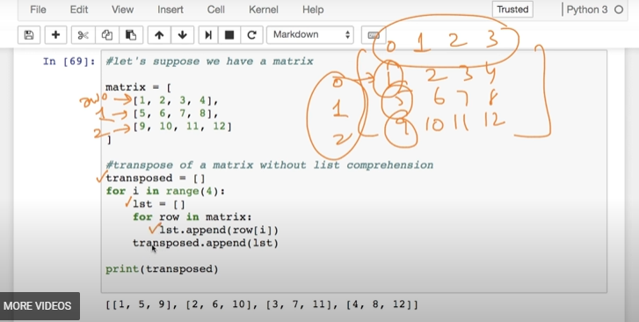

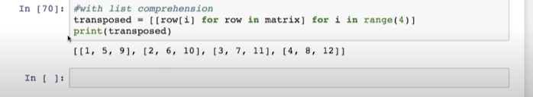

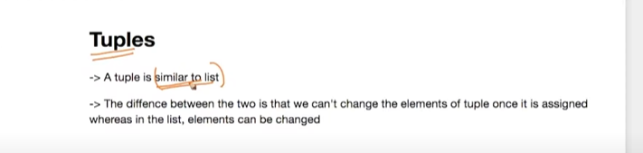

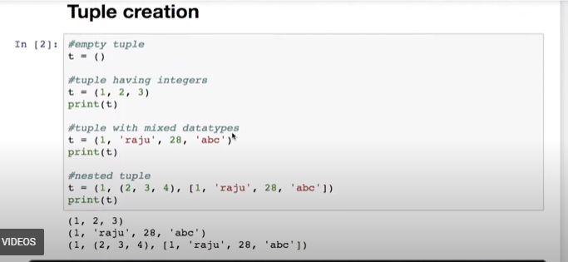

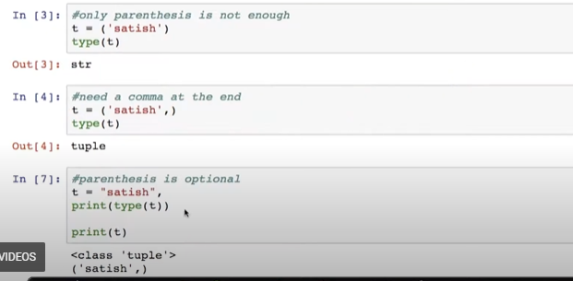

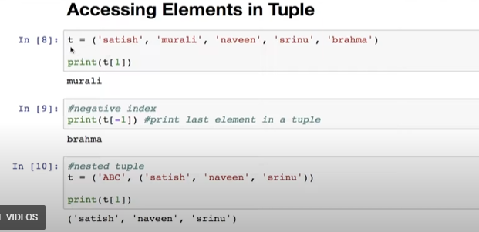



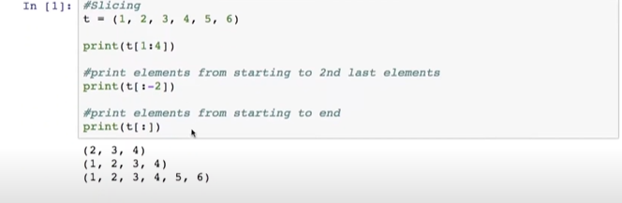

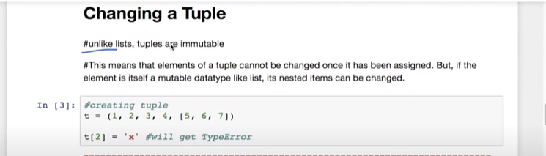

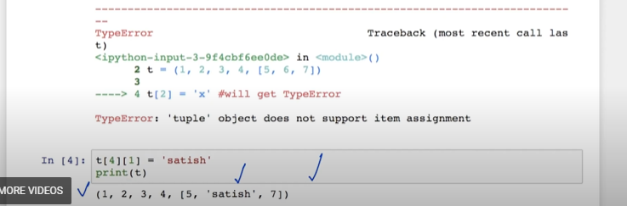

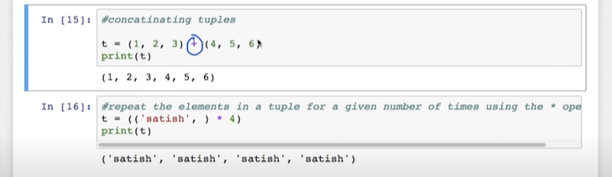

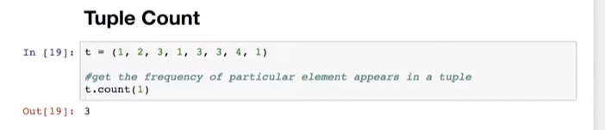

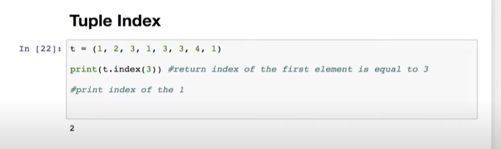

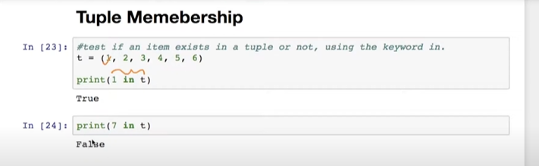

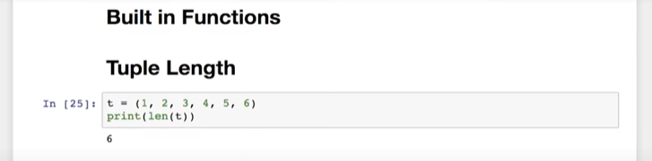

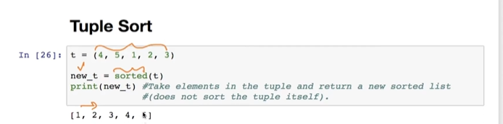

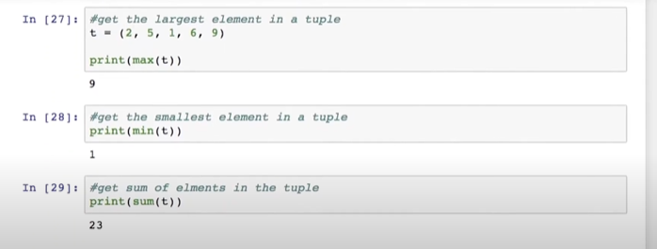

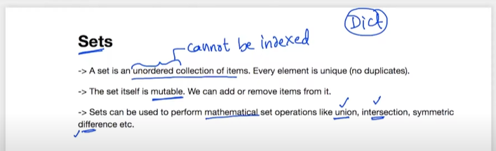

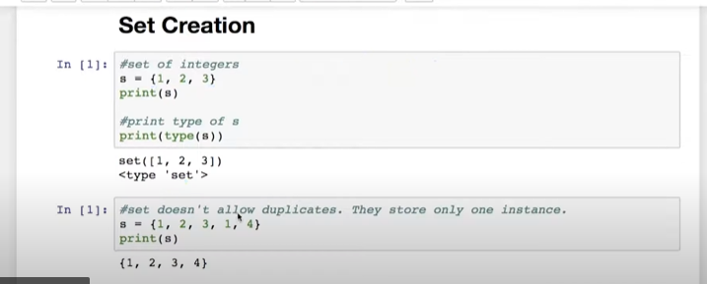

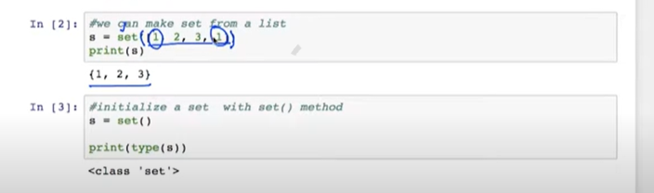

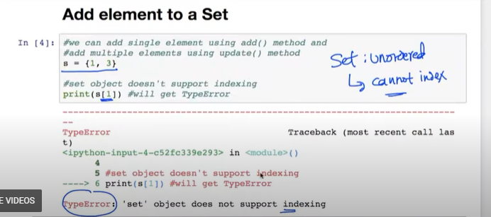

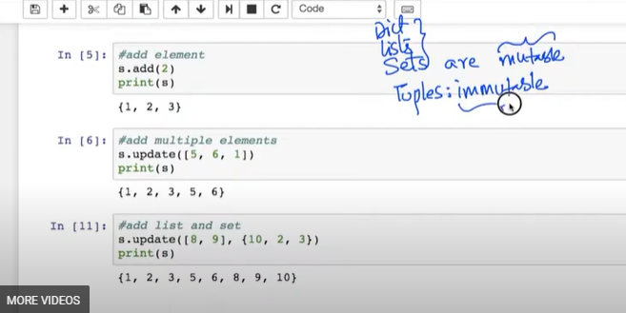

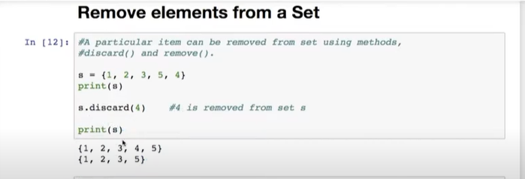

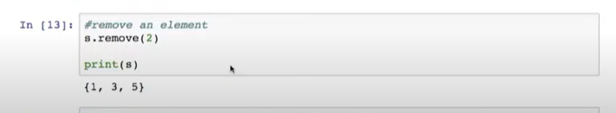

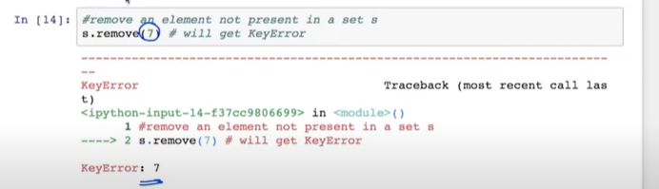

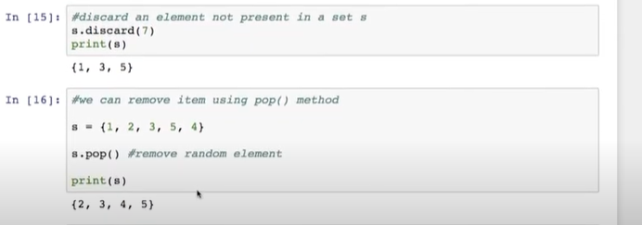

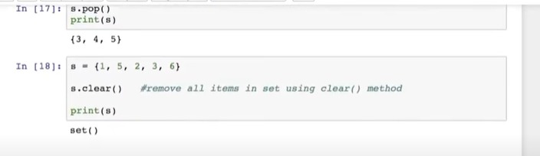

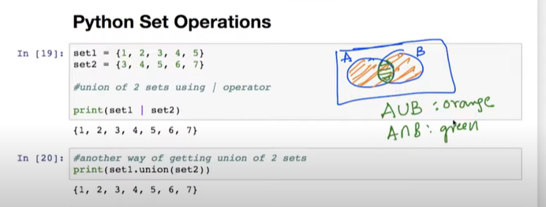

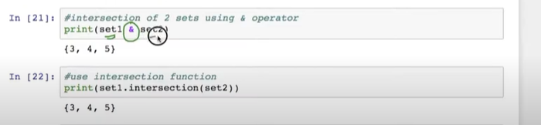

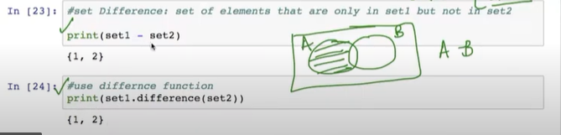

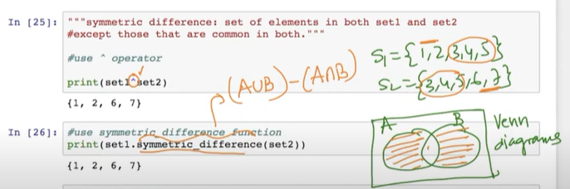

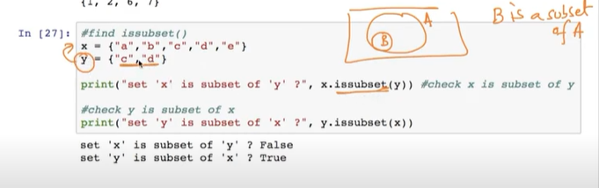

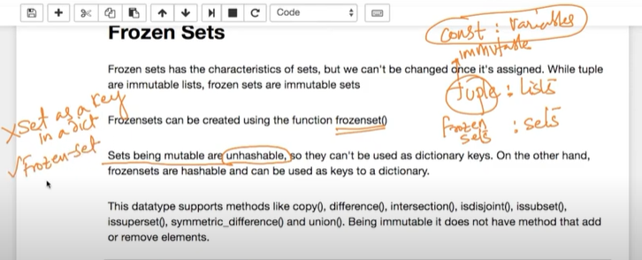

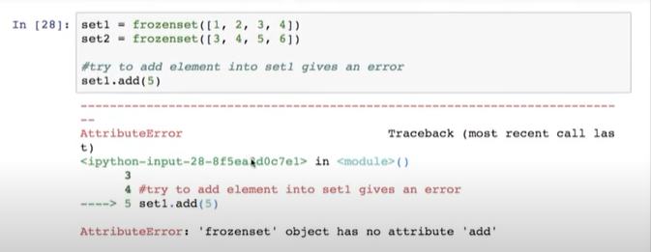

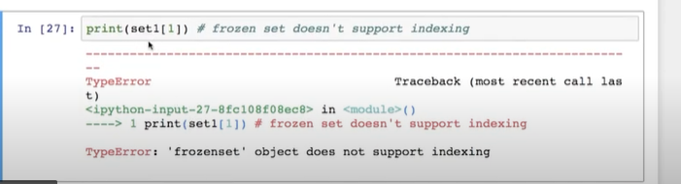

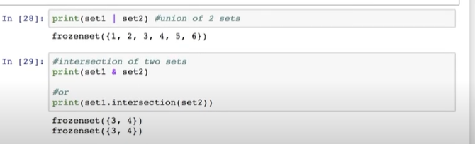

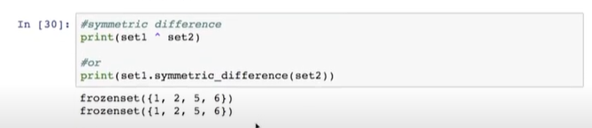

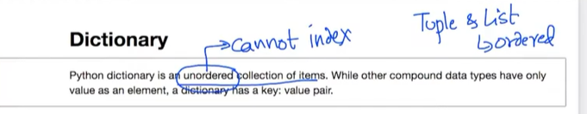

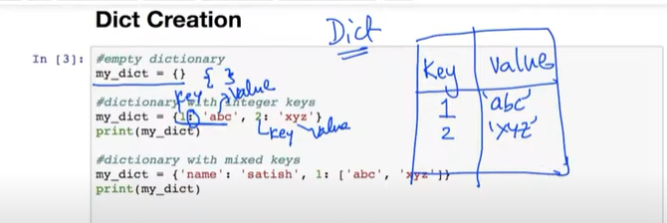

**It stores the values in a table,(hash table in datastructures)**

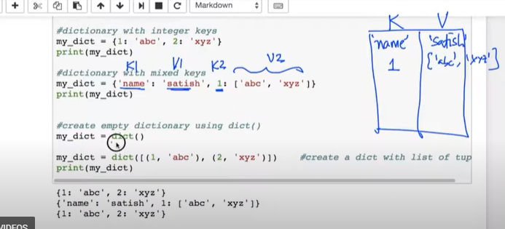

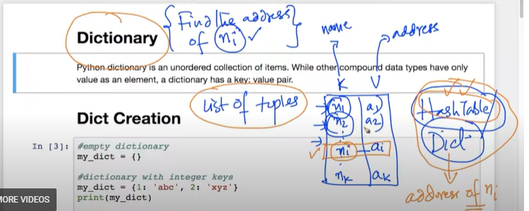

**Suppose If I need the value of (ni) we go through the list of tuples in order for searching the data, dictionery provides advatage for getting data quicker compared to other data structures**

**Dictionery / hash table are most widely used in industry.**

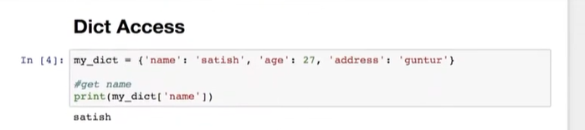

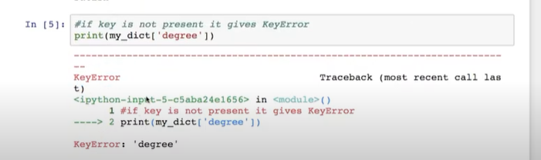

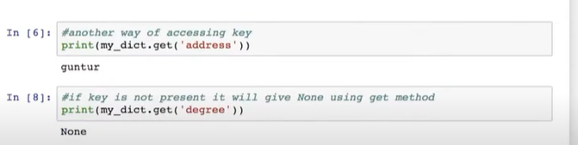

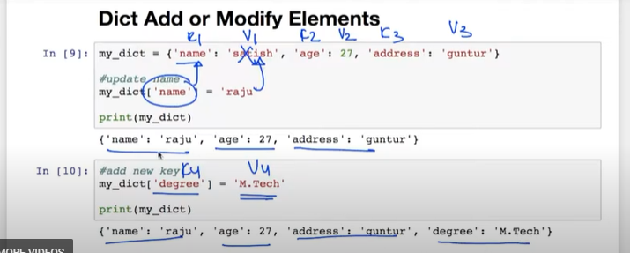

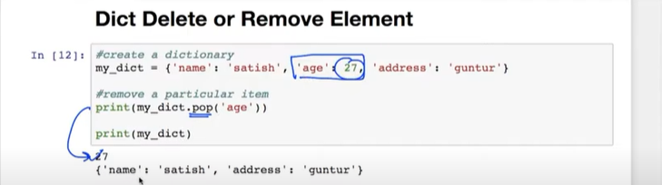

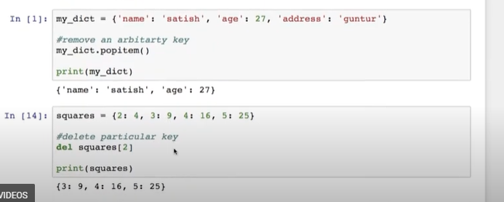

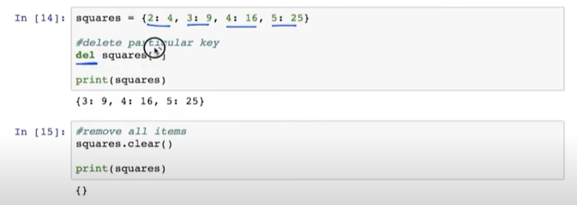

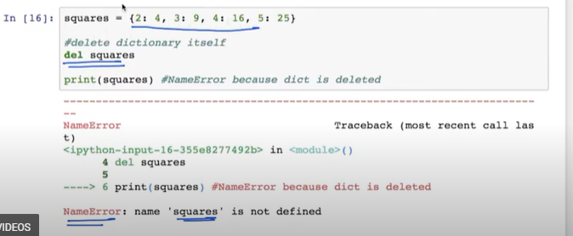

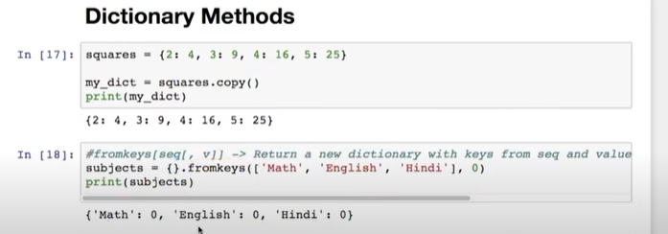

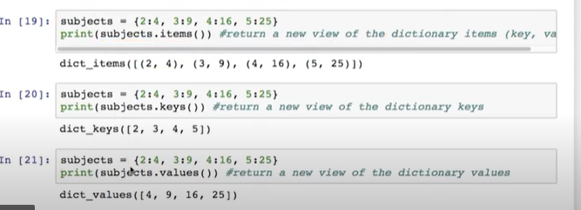

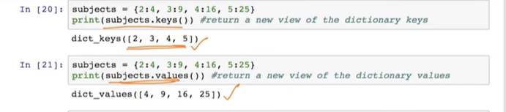

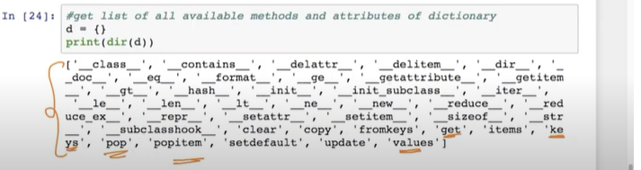

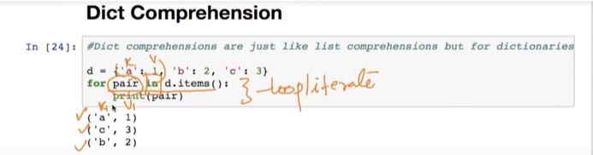

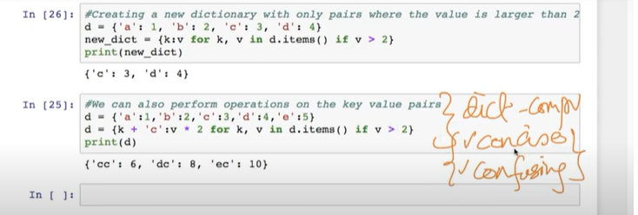

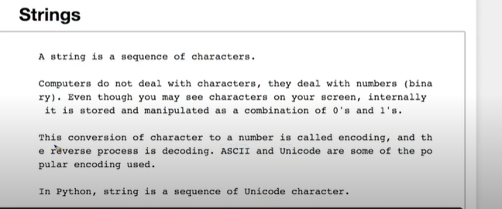

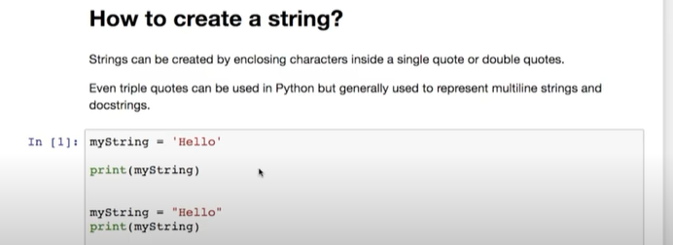

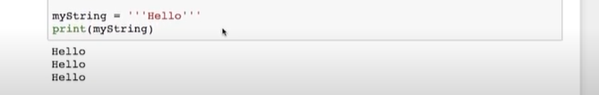

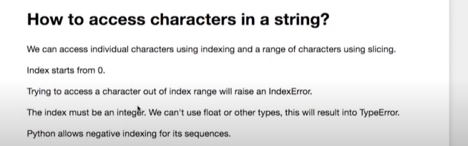

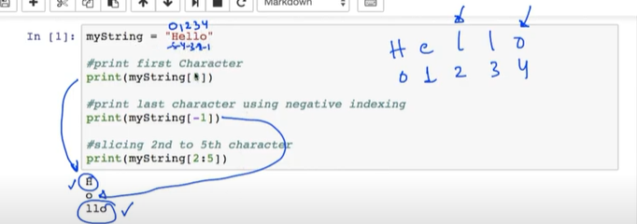

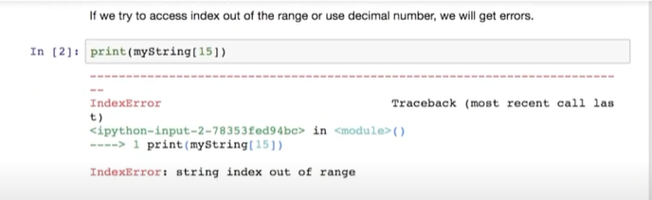

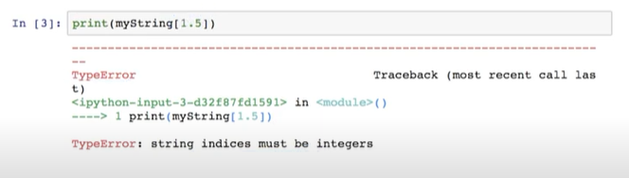

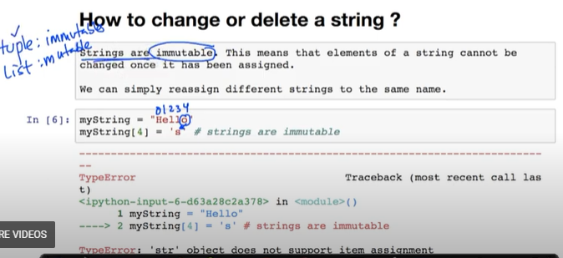

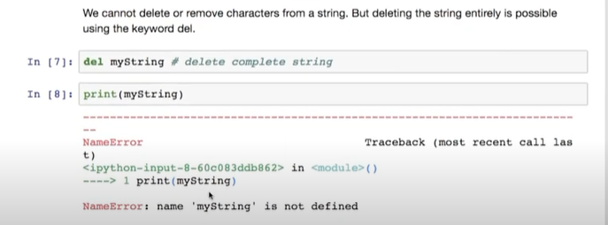

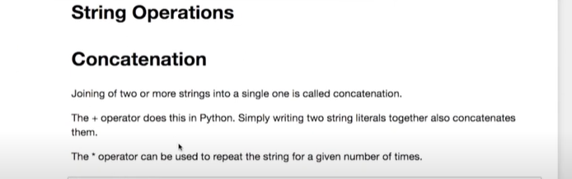

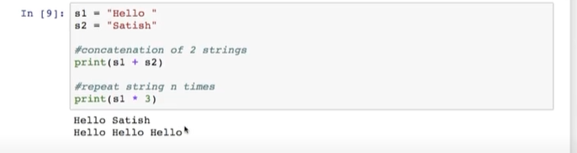

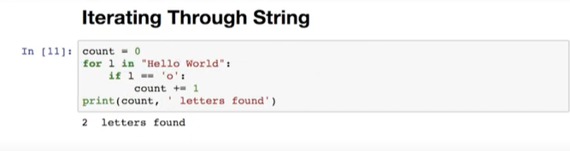

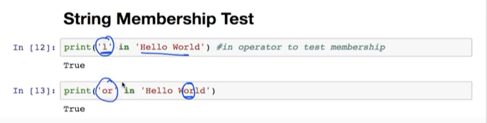

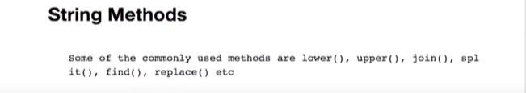

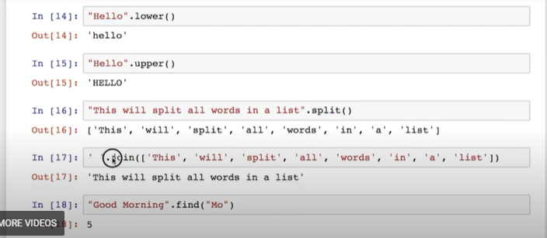



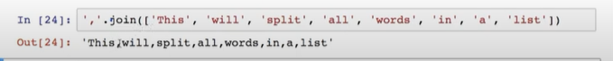

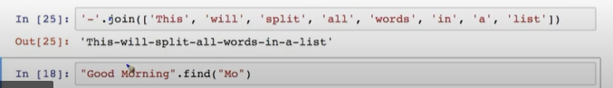

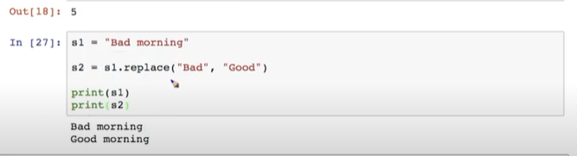

**Python program to check whether the string is palindrome or not**

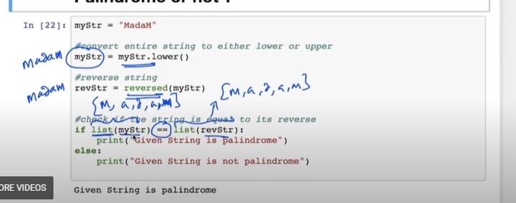

**My string is located to somewhere in the memory ,revstring is pointing to someother location of the memory ,so the best practice to converting the string into list**

